ASSURING QUALITY & RETURN ON INVESTMENT IN HRD
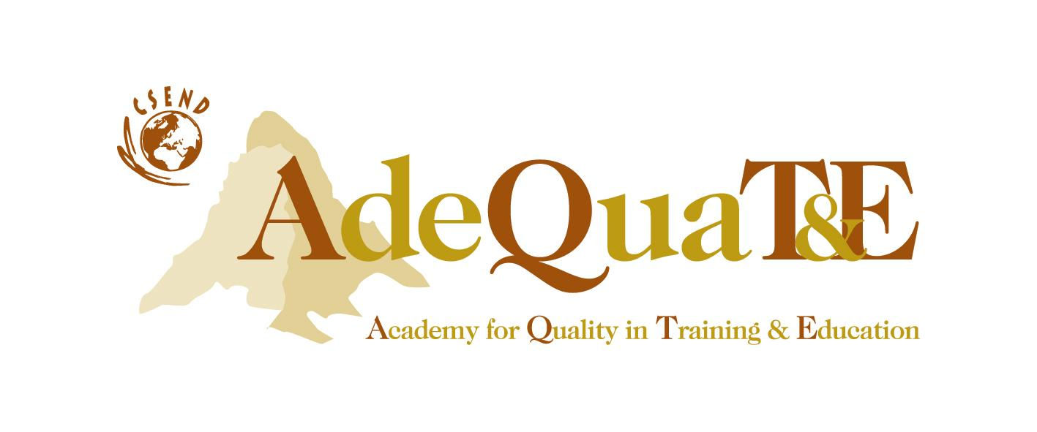
A Strategic HR Function for Corporate Competitiveness
Workshop Overview
Today the competitive companies depend on their learning and innovation capacities to adjust and adapt rapidly to the changing market conditions and demands. This is where the HRD function could make the most contributions resulting in actual business gains.
Training managers need to operate a dynamic management system which fosters continuous improvement and organizational learning in managing its learning and innovative capacities. They also need to operate a reliable tracking system in order to maintain consistency of training quality and to assess return on investment. Most importantly, training managers need to establish "enabling" mechanisms to align training and business objectives in a responsive and timely manner.
ISO 10015 Quality Standard for Training offers the solution to these needs.
Objective of the Workshop
This workshop will demonstrate how corporations can be more effective in building their human capital through training and how training inputs help a company achieve its strategic goals and sustain its competitive advantage. This workshop will provide an overview of the ISO 10015 Standard and ways to build up a ISO 10015 based Training and Development (T&D) platform in order to guarantee desired returns from investment in people.
Who should Attend
The workshop would be very beneficial for department heads, senior executives and managers responsible for HRD, Personnel, Training & Development, Organisation Development, Knowledge management. It would also be very useful for senior executives from functions like strategic planning and quality management.
Workshop Agenda
1. Knowledge as a factor condition for business sustainability
2. Strategic training management
3. Training evaluation and return on Investment
4. ISO 10015 and its core elements
5. External validation and ISO certification
Learning Outcome
Participants will:
- Learn the concept and framework of knowledge based competitive strategy
- Acquire the tools to manage the link between organizational performance and human capital investment
- Know the tools in assessing the return on investment of training
- Understand the implementation requirements of setting up a ISO 10015 quality and management platform
- Know of ISO 10015 Standard in-depth and the benefits of an externally validated quality assurance system

Workshop Instructor / Facilitator
Dr. Lichia Saner-Yiu

She is the President of Academy for Quality in Training and Education (AdeQuaTE®) in Geneva, Switzerland; Co-founder of Organisational Consultants Ltd; Visiting professor at different universities; Consultant in organization development for 3M, BASF, Motorola Daimler-Benz, TCE, BNP Paribas; Lead Auditor for ISO 10015+ certification at Haier Group Company, Shanghai Telecom, Jiangwei Automobile and pre-audits in different MNCs in Switzerland and N. America. She has authored numerous articles, books, chaired international conferences and served on committees of academic organizations. She is an active member of the Academy of Management (Management Education and Development Division) and the International Association of Institutes and Schools of Administration.

WORKSHOP PROGRAMME

Time | Topics
0900 – 0920 hrs | Welcome and Introduction
0920 – 1030 hrs | - Knowledge as a factor condition for business sustainability  - Organisational Learning and Adaptation
1030 – 1100 hrs | Break
1100 – 1200 hrs | - Strategic Training Management: from Administrative Support to Strategic Partner
1200 – 1400 hrs | Lunch
1400 – 1530 hrs | - Training Evaluation and Return on Investment  - ISO 10015 and Its Underlying Principles and Core Elements
1530 – 1545 hrs | Break
1545 – 1700 hrs | - Core Elements ( II)  - System Installation: Considerations and Challenges  - Certification of Training (HRD) Functions and Programmes
1700 hrs | Closing of the Workshop

